
CONSTRUCTION STARTED
Siam Royal Ocean View is a new 7-story luxury condominium with 25 units.
Developed and built by the same group that gave you Siam Ocean View
Also suited in prime location on the Pratamnak hill, between Pattaya and Jomtien.
All the 25 units come with high European standard, and have big Balconies with great views.
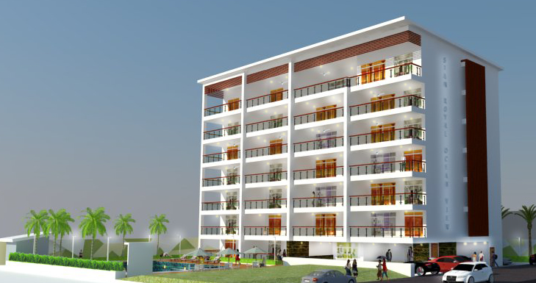

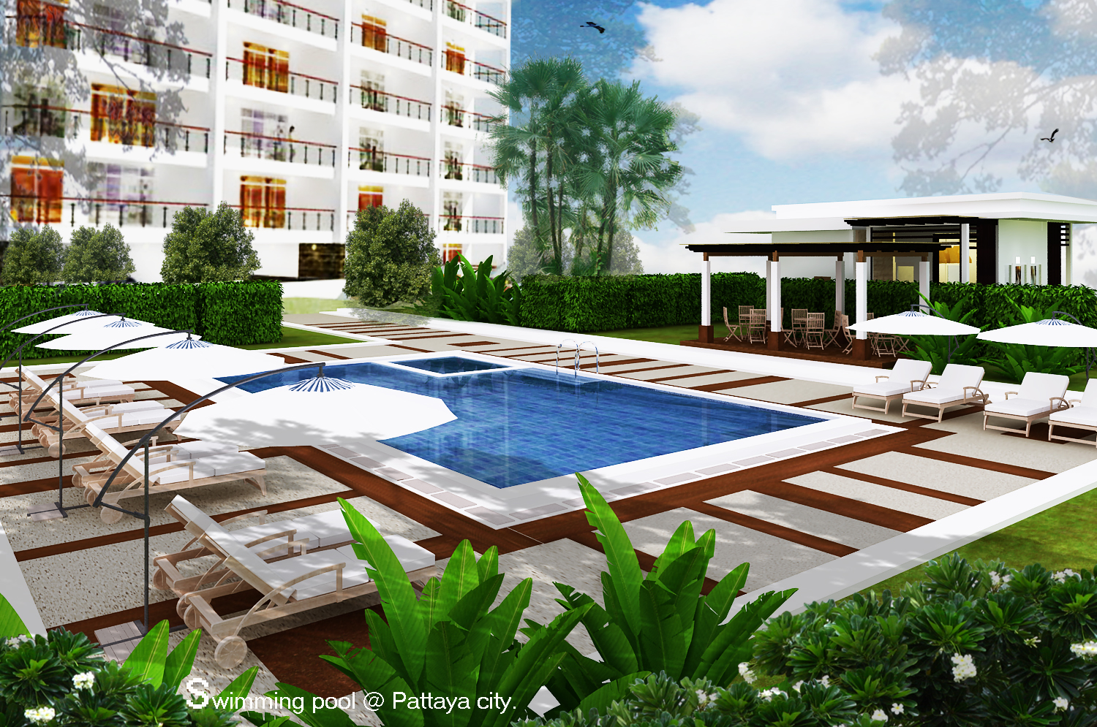
88 % SOLD
http://www.siam-ocean-view.com Email : siamroyaloceanview@gmail.com
Contact: Jan 0885252085. Alf 0871358196. Pom (Thai) 0899388658.

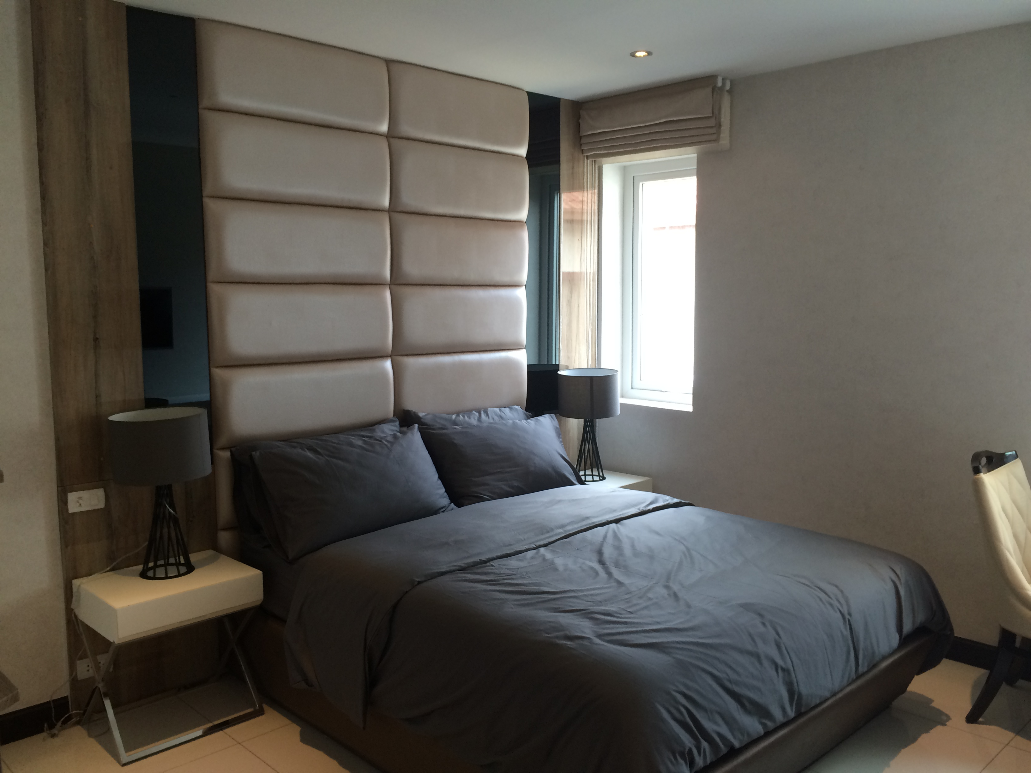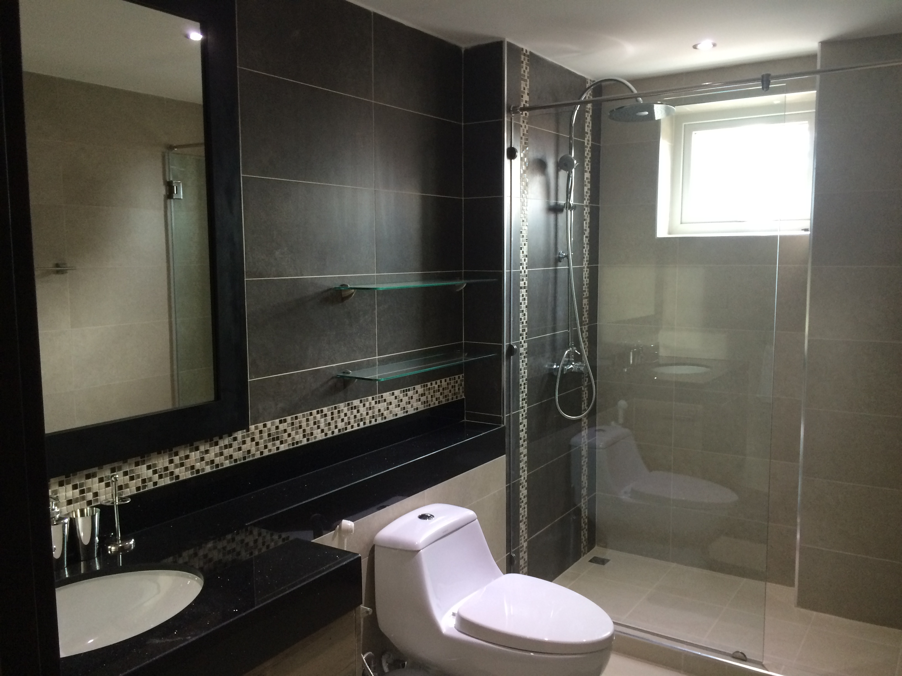

Photo from Show Unit

Facilities and Features

- Reception / Rental service / Maid service.
- Elevator.
- 24hours security.
- CCTV.
- Key Card Access.
- Covered car parking in the basement with direct access to the lift.
- Big Swimming pool and garden.
- Easy access to the beach, Pattaya and Jomtien.
- 20 Golf courses with in 45 min.

Units

- High quality double glass windows and balcony doors.
- Daikin Air conditioner in all bedrooms and all living area.
- Custom made kitchen with built- in Oven and hub.
- Four double soundproof walls between each unit.
- High quality flooring.
- Built-in closets in all bedrooms.
- Wireless Internet and UBC and Sophon TV access in all units.
- All units are completed with high European standard and finish.

Price List
Unit Nr. | Floor 1 | SQM | Bed/Bathroom | Price THB
103 | 1 | 93 | 2/2 | 7 900.000,-
104 | 1 | 126 | 2/2 | 10 900.000,-
Unit Nr. | Floor 2 | SQM | Bed/Bathroom | Price
201 | 2 | 117 | 2/2 | 10 500.000,-
202 | 2 | 91 | 2/2 | SOLD
203 | 2 | 93 | 2/2 | SOLD
204 | 2 | 126 | 2/2 | SOLD
Unit Nr. | Floor 3 | SQM | Bed/Bathroom | Price
301 | 3 | 117 | 2/2 | SOLD
302 | 3 | 91 | 2/2 | SOLD
303 | 3 | 93 | 2/2 | SOLD
304 | 3 | 126 | 2/2 | SOLD
Unit Nr. | Floor 4 | SQM | Bed/Bathroom | Price
401 | 4 | 117 | 2/2 | SOLD
402 | 4 | 91 | 2/2 | SOLD
403 | 4 | 93 | 2/2 | SOLD
404 | 4 | 126 | 2/2 | SOLD
Unit Nr. | Floor 5 | SQM | Bed/Bathroom | Price
501 | 5 | 117 | 2/2 | SOLD
502 | 5 | 91 | 2/2 | SOLD
503 | 5 | 93 | 2/2 | SOLD
504 | 5 | 126 | 2/2 | SOLD
Unit Nr. | Floor 6 | SQM | Bed/Bathroom | Price
601 | 6 | 117 | 2/2 | SOLD
602 | 6 | 91 | 2/2 | SOLD
603 | 6 | 93 | 2/2 | SOLD
604 | 6 | 126 | 2/2 | SOLD
Unit Nr. | Floor 7 | SQM | Bed/Bathroom | Price
701 | 7 | 234 | 3/2 | SOLD
703 | 7 | 93 | 2/2 | SOLD
704 | 7 | 126 | 2/2 | SOLD

We also offer in-house finance on a limited number of units.

This price list can be changed without prior notes!

COMMON FEES
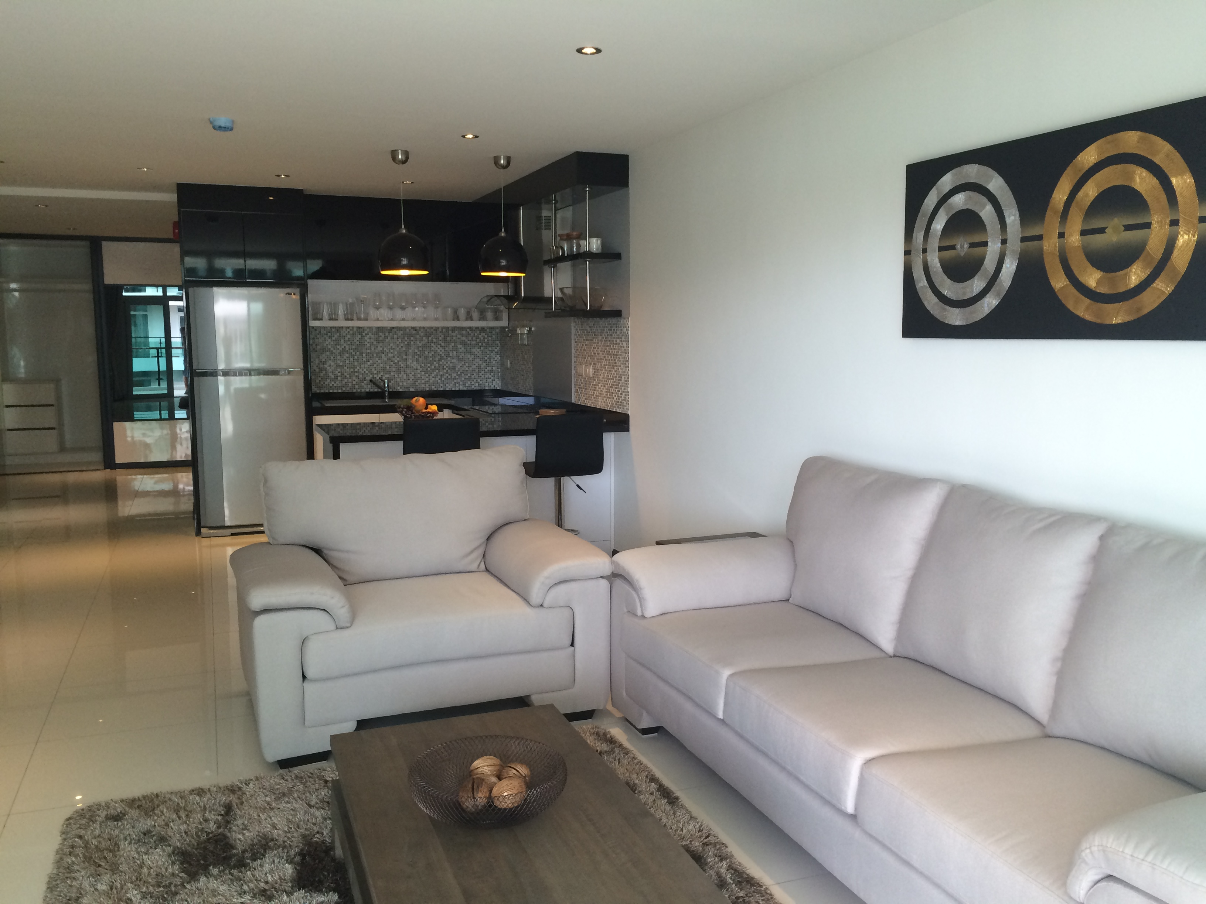
35 Baht sqm. Month: Common fees are paid on a yearly basis.

Includes as follows
Management.
Insurance of main area.
Reception.
Security.
Garden.
Pool Cleaning.
Electrics common area.
Water supply common area.
Cleaning of common area.

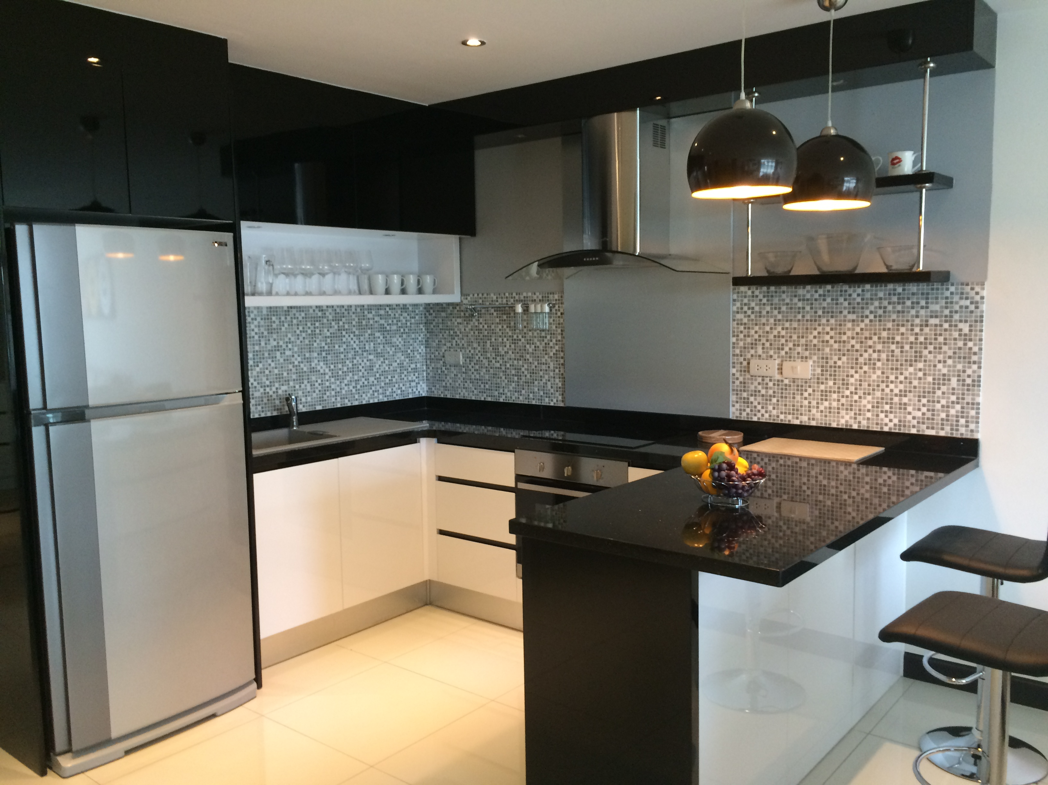
Photo from Show Unit

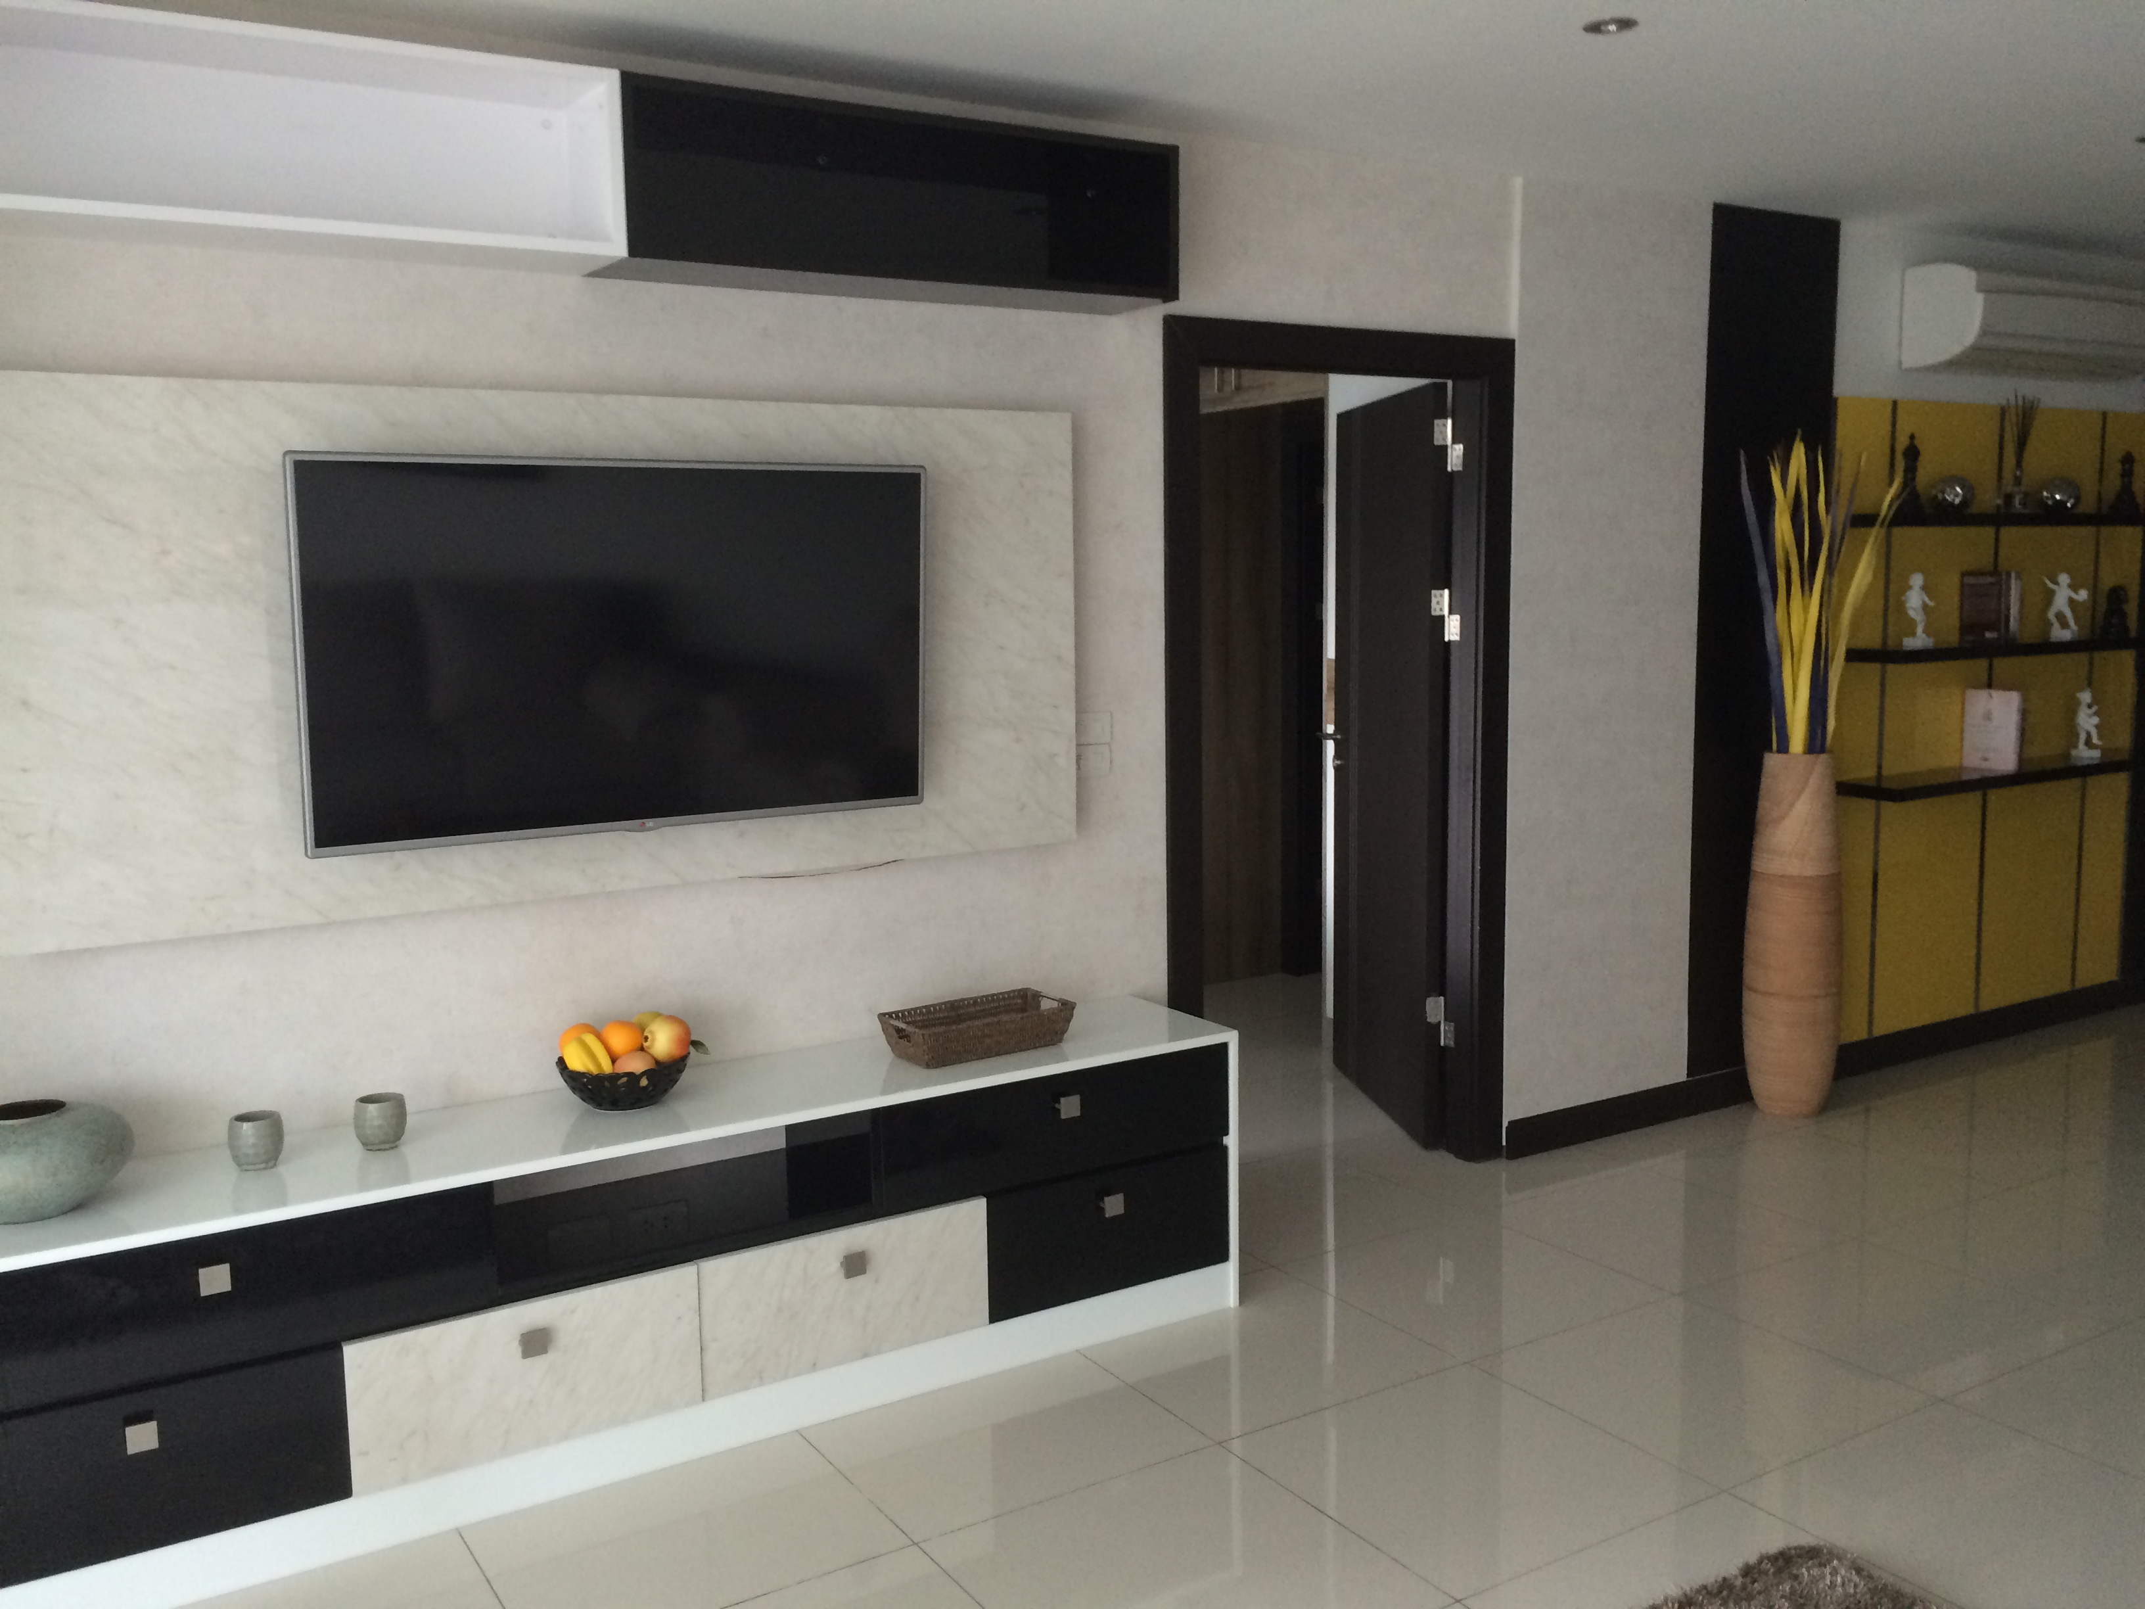
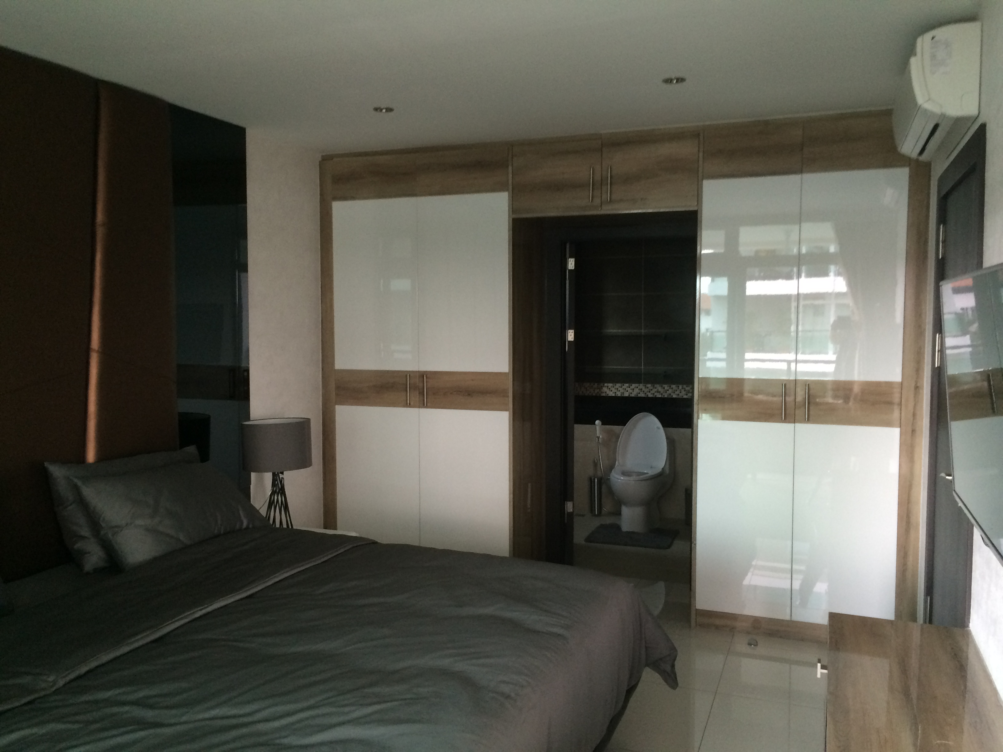
Photo from Show Unit

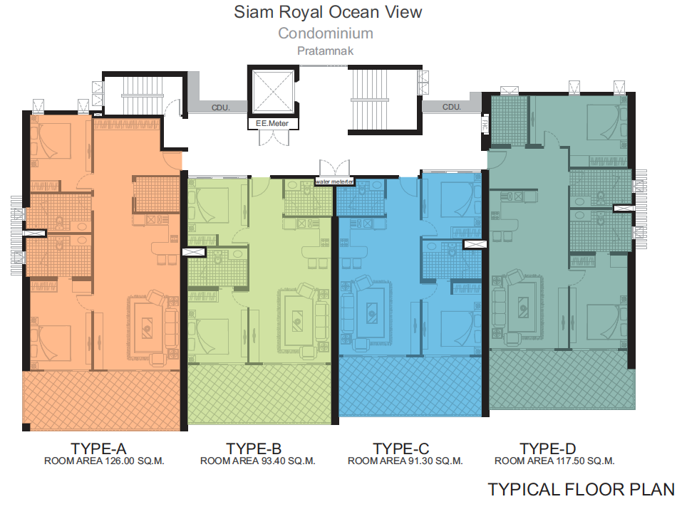

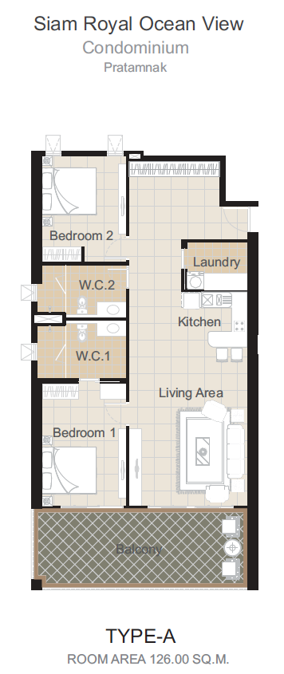
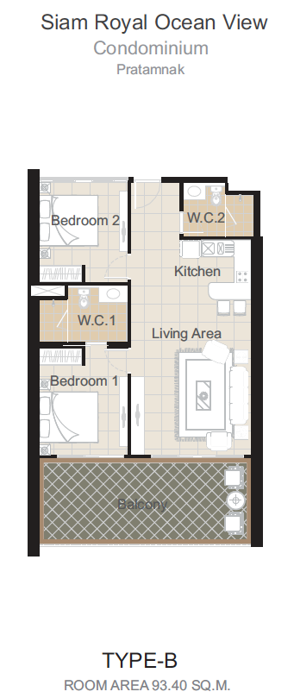
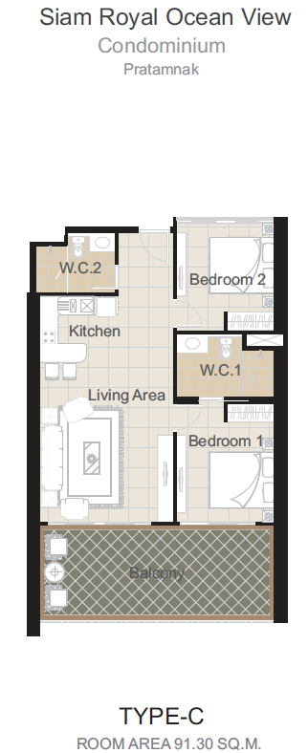
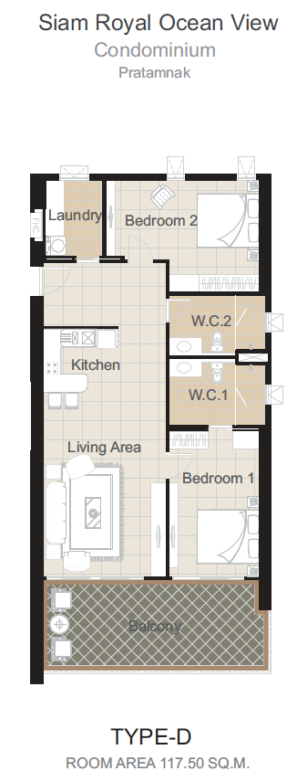
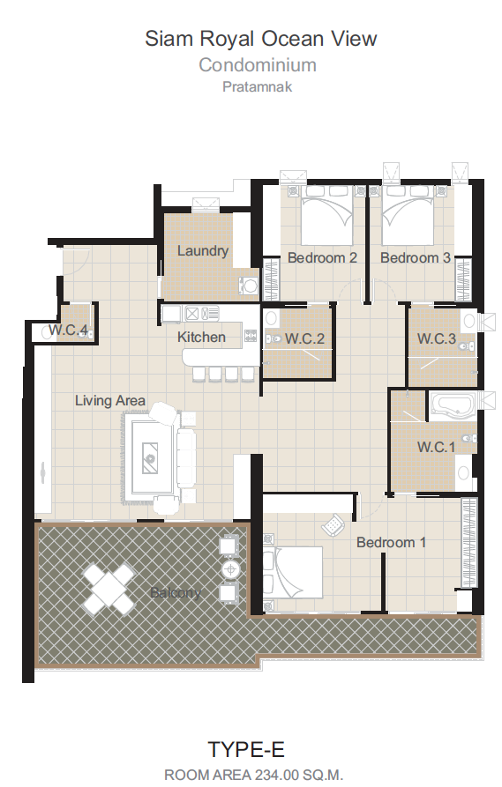

RESERVATION

Binding/Reservation for purchasing in Siam Royal Ocean View

Siam Royal Ocean View

Condominium no:

I/we give this current offer on the property shown above:

Sales cost will be payable as follows:

At reservation. 100 000, - (One Hundred Thousand Baht)
At signing. Of contract (15 days after reservation) 10 % of sales cost in Baht:
At start of construction 15 % of sales cost in Baht:
At completion of concrete on 3rd floor. 15 % of sales cost in Baht:
At completion of concrete on the roof. 15 % of sales cost in Baht:
Upon installation of all windows. 15 % of sales cost in Baht:

When ready for occupation 30% of sales cost in Baht:

Sum Baht.

The offer is binding for the buyer. If the seller accepts the offer, this reservation contract will be recognized as the preliminary contract between seller and buyer until the final contract is completed and signed. If the buyer should choose to break this contract the deposit belongs to the seller of the property.

Name
Date of birth.
Address.
E-Mail.
Phone/mobile.

Passport.nr.

Place, Date

________________________________________________________________________
sign. sign.

Buyer Seller

